**Project Design Phase-II**

**Technology Stack (Architecture & Stack)**

|  |  |
| --- | --- |
| Date | 03October 2022 |
| Team ID | PNT2022TMID40586 |
| Project Name | IOT Based Industry Specific Intelligent Fire Management System |
| Maximum Marks | 4 Marks |

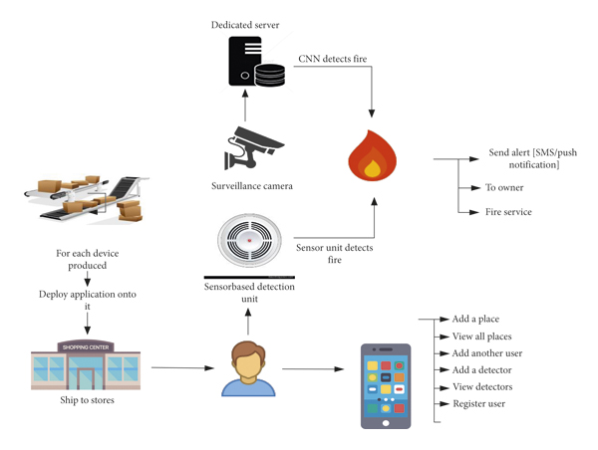

Guidelines:

* 1.Install smoke alarms on every level of your home, inside bedrooms and outside sleeping areas.
* 2.Test smoke alarms every month. ...
* 3.Talk with all family members about a fire escape plan and practice the plan twice a year.
* 4.If a fire occurs in your home, GET OUT, STAY OUT and CALL FOR HELP.

**Table-1 :Components & Technologies:**

|  |  |  |  |
| --- | --- | --- | --- |
| **S.No** | **Component** | **Description** | **Technology** |
|  | User Interface | How user interacts with application Mobile App, | HTML, CSS, JavaScript / Angular Js / React Js etc. |
|  | Application Logic-1 | Logic for a process in the application | Java / Python |
|  | Database | Data Type, Configurations etc. | MySQL, NoSQL, etc. |
|  | Cloud Database | Database Service on Cloud | IBM DB2, IBM |
|  | File Storage | File storage requirements | IBM Block Storage or Other Storage Service or Local Filesystem |
|  | External API-1 | Purpose of External API used in the application | IBM Weather API, etc. |
|  | Infrastructure (Server / Cloud) | Application Deployment on Local System / Cloud  Local Server Configuration:  Cloud Server Configuration : | Local, Cloud Foundry, Kubernetes, etc. |